Creation of bench repair work order.

Two of bench repair WO’s are available.

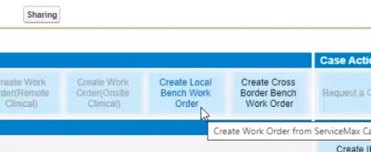

Create Local Bench Work order: Within Same county

Create Cross Border Bench Work order: different counties.

Note: Account data should match in both SMAX, and SAP. ( SalesOrg)

Company will take the IP to their location and they will fix it.

1)Login as agent

2)check the warrant or contract covered for bench repair.

3)Create a bench create a case by click on Create bench receipt as shown below

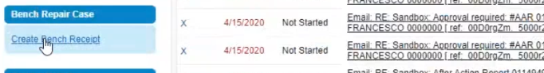4)And Click on Save

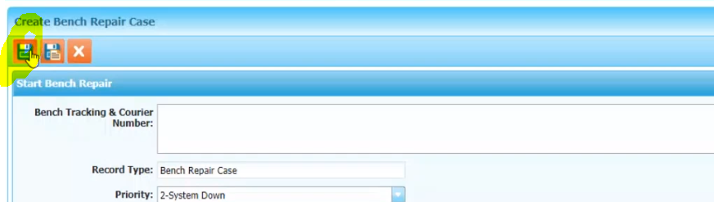

5)Click on Update tracking / Courier Number.

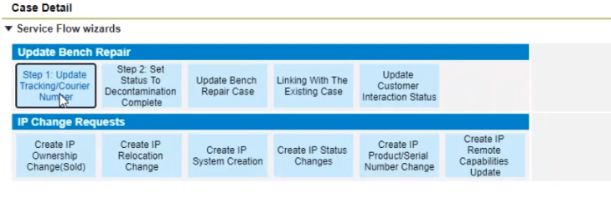

6)Give any unique number and click on Save.

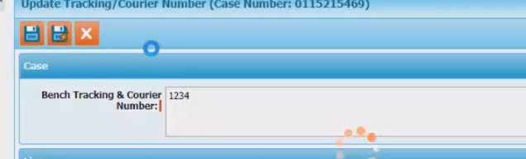

7)Click on the Step 2: Set Status To Decontainination complete

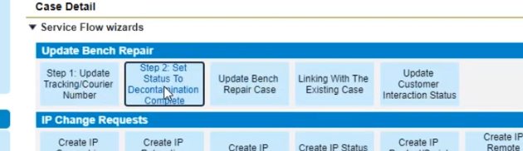

8)Click on Save

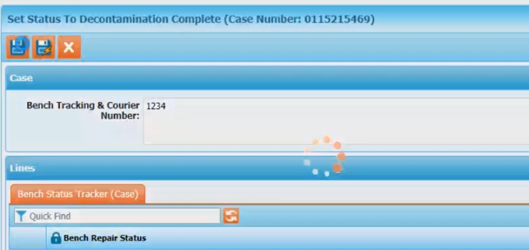

9) Click on Update Bench Repair Case

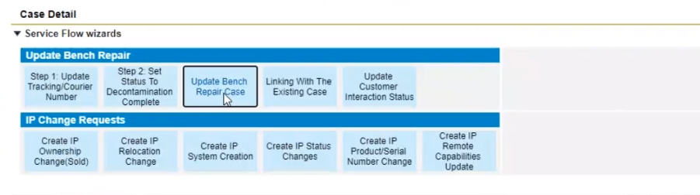

10) Provide the IP and search ,

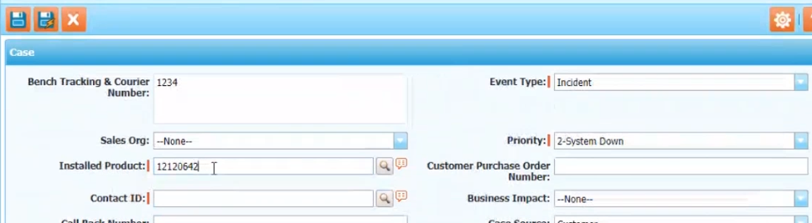

Verify that Account , Sales Orgs, Product are populated .

Pick the Contact ID

11) Provide any random description

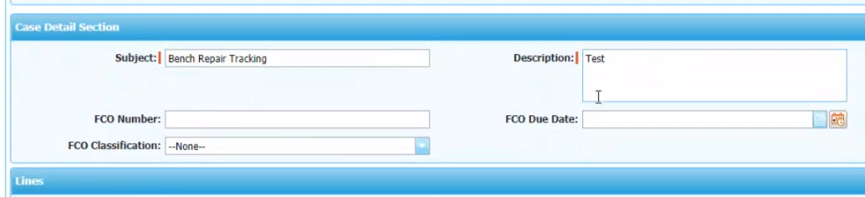

12)Click on Save

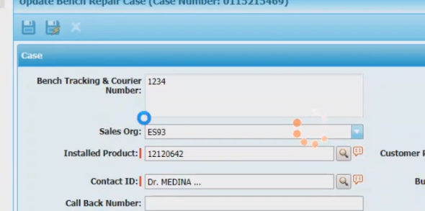

13)Fill the Safety Questions

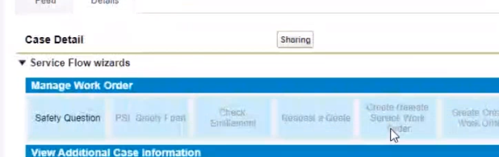

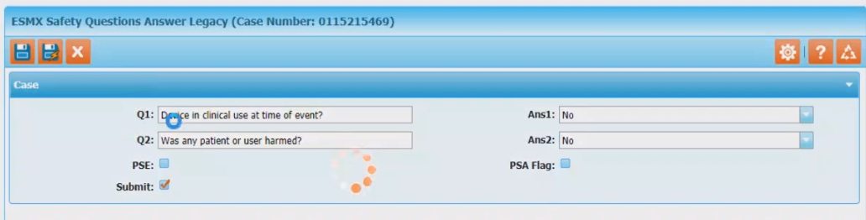

14)If the request Bench Assessment is not checked then check it so that bench repair work order

SFM will enabled and click on Save.

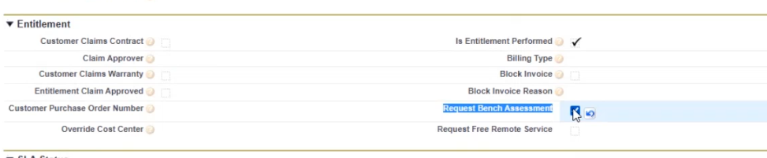

15)Based on the need, click on the Create local Bench Work order / cross border bench work order

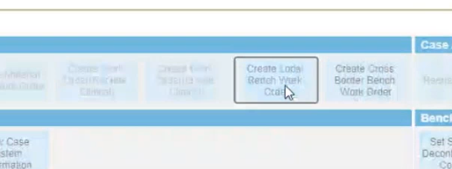

16)Click on Initiate SWO

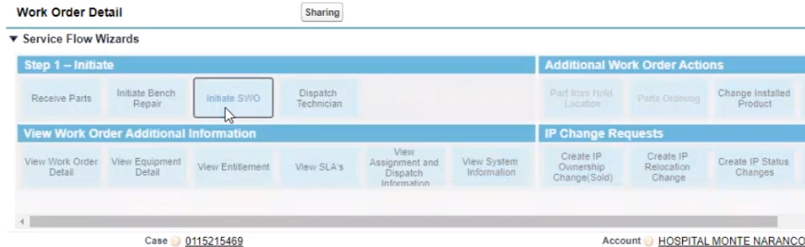

Verify SWO number created or not.

17) Click on Parts Ordering

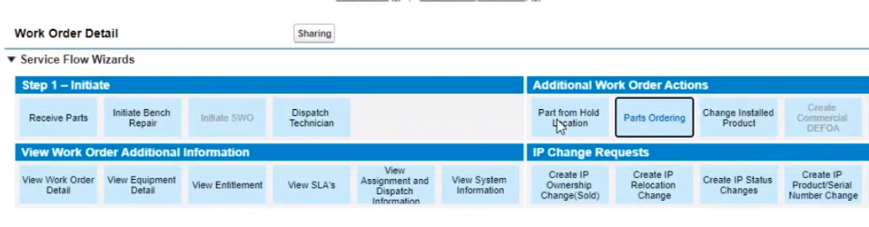

18)Provide the product code and click on search and click on add

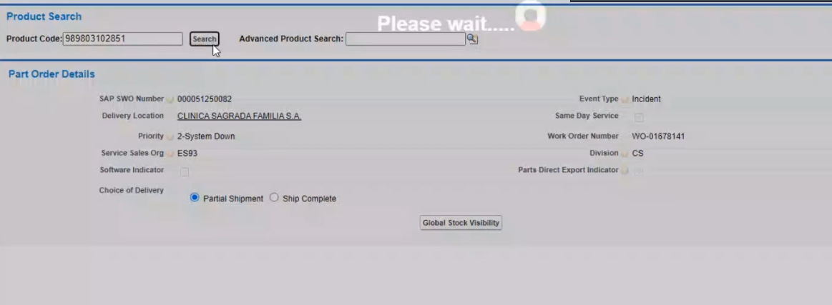

19)Do the get entitlement & GATP Simulation `and Click on transfer to SAP.

20) Ask SAP team to do the PGI and after that check the Line status as “Shipped”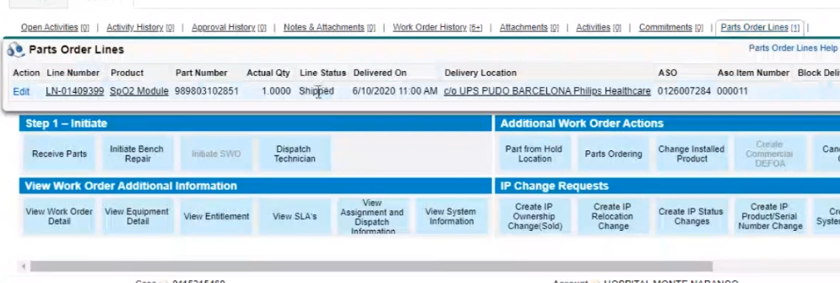

21) For cross border, we have to check the “Out of Country Bench”

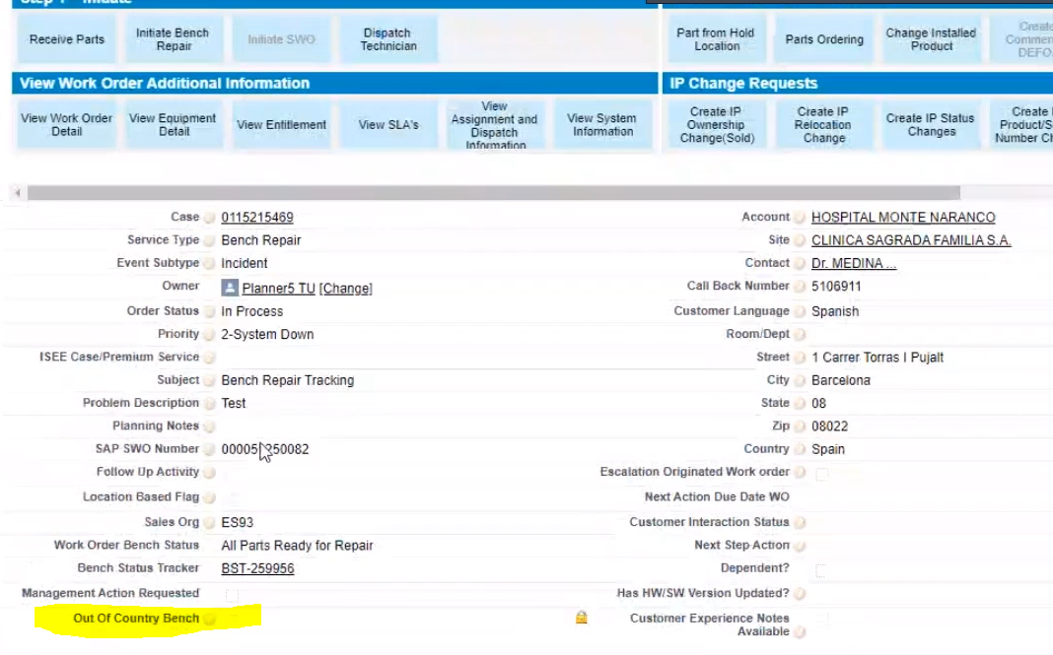

Demo data:

